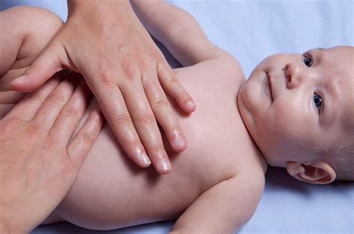

  - Infant MASSAGE cLASSES
  - lEARN HOW TO MASSAGE YOUR BABY
  - iNTERNATIONAL aSSOCIATION OF iNFANT mASSAGE METHOD
  - (iaim)
  - iNFANT MASSAGE hAS mANY hEALTH bENEFITS

  - a fIVE-WEEk sERIES
  - Infants o - 6 months
  - tUESDAY mAY 2, 9, 16, 23, 30
  - 10AM-11:30am
  - iNSTRUCTOR: sUSAN hOWLETT

  - lOCATION: sWAN hEALTH CENTRE
  - 587 kING sTREET
  - pETERBOROUGH
(Center is at end of driveway behind house)
To register for free: email: sh@gardenstudio.ca or call (705) 930-0381
Accepting 6 mothers and infants

